 | Epsom & Ewell  12  v  Dorking Wanderers Reserves  Tuesday, 27th November 2018 – 7.45 p.m.
Good evening! We welcome the players, supporters and officials of Dorking Wanderers Reserves to High Road for tonight’s League match. We also welcome back our former Coach Jordan Clark who is now in charge of our opponents as well as our former Caretaker Manager Peter Augustine, who was in charge for six weeks in 2006 in between the departure of Paul Pritchard and the appointment of Lyndon Buckwell. We also may see former players Ben Dyson, Rory Sellick, Louis O’Brien and Josh Burt on show this evening too.

We met back in September and led 2-1 at half time, only to concede a few late goals to lose 5-3. Since that time their form has not been quite so good, while ours has picked up under Simon Funnell, but as with our recent draw with Kensington Borough, you can afford to take no team lightly in this league.

We were last here seven days ago when we hosted Dorkinian in the Surrey Premier Cup and after a slow start, went through the gears to win 4-0 in the end with Liam Roberts scoring two good goals and making a third for Olly Martinez. However, Elliott Thompson’s second goal for the club was brilliant and it is great to see him back on the scoresheet after coming through a horrible injury. The goal was his first for over two years after he first registered for us at Bedfont & Feltham in that famous 9-2 win.

Then on Saturday we made our first ever visit to Eversley & California, where we didn’t produce anything like our best form and went down 2-1. Adam Heagney started and finished a fine flowing move to equalise at one point, but it was the only highlight from a depressing afternoon.

In the League Cup we have been drawn at home to Godalming Town with a place in the Quarter-Finals for the winners, while in the Quarter Finals of the Division One Cup we have been drawn away at Bedfont & Feltham. We await our Surrey Premier Cup Quarter-Final draw and will of course let you know when it is available.

Going forward, we are back here on Saturday as we host Godalming Town and we follow that seven days later with a home tie against leaders Bedfont & Feltham. Please keep following the Salts as we need your support!

Enjoy the game!

Rich

You can follow us on Facebook: www.facebook.com/epsomandewellfc
Twitter: @EEFCOfficial Instagram at: www.instagram.com/epsomandewellfc
and Youtube at: www.youtube.com/channel/UCtLrpS0x5OaYUACRT34_zng

Cover photo

The two teams line up at Eversley & California before our 2-1 defeat on Saturday


Cherry Red Records Combined Counties League
Division One Table 2018/19
inc Saturday 24th November 2018 | P | W | D | L | F | A | Pts | GD | H | A
Bedfont & Feltham | 15 | 11 | 3 | 1 | 53 | 13 | 36 | +40 | 8/12 | 13/4
Frimley Green | 17 | 10 | 5 | 2 | 33 | 22 | 35 | +11 | 3-0 | 23/2
Sheerwater | 16 | 10 | 3 | 3 | 37 | 23 | 33 | +14 | 2-3 | 22/12
Farnham Town | 15 | 9 | 4 | 2 | 33 | 13 | 31 | +20 | 2/2 | 1-4
Tooting Bec | 16 | 9 | 2 | 5 | 32 | 22 | 29 | +10 | 3-1 | 30/3
Epsom & Ewell | 16 | 9 | 1 | 6 | 37 | 27 | 28 | +10 | X | X
Dorking Wanderers Res | 17 | 8 | 3 | 6 | 40 | 34 | 27 | +6 | 27/11 | 3-5
Sandhurst Town | 15 | 8 | 3 | 4 | 24 | 25 | 27 | -1 | 20/4 | 2-0
Ash United | 16 | 7 | 4 | 5 | 42 | 35 | 25 | +7 | 12/1 | 2-1
British Airways | 17 | 7 | 3 | 7 | 39 | 38 | 24 | +1 | 16/2 | 2-3
Chessington & Hook Utd | 15 | 7 | 2 | 6 | 28 | 28 | 23 | 0 | 1-2 | 4-1
Eversley & California | 14 | 5 | 1 | 8 | 31 | 36 | 16 | -5 | 29/12 | 1-2
Bagshot | 17 | 4 | 2 | 11 | 17 | 56 | 14 | -39 | 19/1 | 3-0
Godalming Town | 14 | 3 | 3 | 8 | 17 | 30 | 12 | -13 | 1/12 | 26/1
Kensington Borough | 16 | 3 | 3 | 10 | 24 | 42 | 12 | -18 | 1-1 | 9/3
FC Deportivo Galicia | 15 | 2 | 3 | 10 | 22 | 29 | 9 | -7 | 12/3 | 3-0
Fleet Spurs | 15 | 3 | 0 | 12 | 25 | 43 | 9 | -18 | 6/4 | 3-2
Cove | 14 | 2 | 1 | 11 | 17 | 35 | 7 | -18 | 3-2 | 5/1

AC London (removed) | 15 | 9 | 2 | 4 | 36 | 25 | 29 | +11 | - | 6-0

Lucky Day? – 27th November
Played 17 - Won 9 Drawn 3 Lost 5 - For 39 Against 30 - PPG 1.76 - Good
Our Club record against Dorking Wanderers Reserves
Played 1 - Won 0 Drawn 0 Lost 1 - For 3 Against 5 - PPG 0.00
Dorking Wanderers Reserves‘ last visit
This is their first visit

First Eleven Appearances 2018/19 - (max 25)
Name | Debut | 2018/19 |  |  |  | Career Totals
Name | Debut | App | Sub | Tot | Goals | App | Sub | Tot | Goals
BENNETT Bobby | 12/08/2018 | 19 | 0 | 19 | 12 | 19 | 0 | 19 | 12
BETANCOURT Steve | 18/08/2018 | 19 | 1 | 20 | 1 | 19 | 1 | 20 | 1
BORRETT Ricky | 04/08/2018 | 9 | 0 | 9 | 0 | 9 | 0 | 9 | 0
CAMPBELL Kieran* | 29/09/2012 | 7 | 3 | 10 | 2 | 59 | 3 | 62 | 2
CAMPBELL Theo | 28/08/2018 | 2 | 9 | 11 | 1 | 2 | 9 | 11 | 1
CAULCRICK Joshua | 17/02/2018 | 0 | 3 | 3 | 0 | 0 | 4 | 4 | 0
CONNELLY Lloyd | 14/10/2017 | 25 | 0 | 25 | 4 | 55 | 4 | 59 | 5
DOBRAJ Endrit* | 18/11/2017 | 5 | 2 | 7 | 1 | 24 | 6 | 30 | 1
DYSON Ben* | 12/08/2017 | 0 | 1 | 1 | 0 | 28 | 14 | 42 | 2
ELGAR Luke | 04/08/2018 | 6 | 3 | 9 | 1 | 6 | 3 | 9 | 1
ELGAR Scott | 12/08/2018 | 4 | 9 | 13 | 0 | 4 | 9 | 13 | 0
GAFFNEY Luke * | 16/08/2014 | 2 | 2 | 4 | 0 | 12 | 3 | 15 | 0
GAYLE Roy | 06/11/2018 | 3 | 0 | 3 | 0 | 3 | 0 | 3 | 0
GILL George | 28/08/2018 | 2 | 0 | 2 | 0 | 2 | 0 | 2 | 0
GRIFFIN Reisse | 08/08/2015 | 14 | 0 | 14 | 2 | 118 | 13 | 131 | 10
HEAGNEY Adam | 16/08/2016 | 25 | 0 | 25 | 1 | 92 | 13 | 105 | 3
HENDRY Rob | 08/08/2015 | 10 | 0 | 10 | 7 | 94 | 23 | 117 | 35
JEANNOEL Germaine | 02/12/2017 | 0 | 9 | 9 | 2 | 2 | 16 | 18 | 3
JONES David | 31/08/2018 | 6 | 2 | 8 | 0 | 6 | 2 | 8 | 0
LOFTUS-CHEEK Joe | 06/08/2017 | 0 | 1 | 1 | 0 | 14 | 8 | 22 | 6
MARTINEZ Olly | 29/09/2018 | 6 | 2 | 8 | 2 | 6 | 2 | 8 | 2
MCKAY Alex | 20/12/2008 | 1 | 0 | 1 | 0 | 163 | 39 | 202 | 13
MORGAN Sam | 11/09/2018 | 2 | 4 | 6 | 0 | 2 | 4 | 6 | 0
MURPHY Scott | 20/01/2007 | 22 | 0 | 22 | 2 | 69 | 2 | 71 | 6
ROBERTS Liam | 12/08/2017 | 18 | 2 | 20 | 10 | 39 | 16 | 55 | 15
SMITH Taryn | 28/10/2017 | 6 | 6 | 12 | 5 | 14 | 10 | 24 | 5
SULLIVAN Ryan | 04/08/2018 | 14 | 1 | 15 | 0 | 14 | 1 | 15 | 0
SUTHERLAND Mitchel | 04/08/2018 | 1 | 1 | 2 | 0 | 1 | 1 | 2 | 0
THOMPSON Elliott | 09/02/2016 | 17 | 2 | 19 | 1 | 27 | 11 | 38 | 2
WATTS Jamie | 03/11/2018 | 4 | 0 | 4 | 0 | 4 | 0 | 4 | 0
WHITE Sean | 02/08/2014 | 9 | 4 | 13 | 4 | 29 | 25 | 54 | 9
WOODCOCK Josh | 22/09/2018 | 1 | 0 | 1 | 0 | 1 | 0 | 1 | 0
WRIGHT Kieran* | 15/09/2018 | 3 | 3 | 6 | 0 | 3 | 3 | 6 | 0
YOUNG Conor | 07/03/2015 | 13 | 0 | 13 | 0 | 46 | 0 | 46 | 0
* - Player has left the club

Surrey Premier Cup
First Round
Carshalton Athletic U19 | w/o Ash | Ash United
Shene Old Grammarians | 2-4 | Old Wilsonians
Lingfield | 5-1 | Horley Town Reserves
Alfold | 2-0 | Godalming Town
Epsom & Ewell | 5-0 | Knaphill U23
Reigatians | 0-4 | Frimley Green
Met Police Reserves | 5/12 | FC Deportivo Galicia
Second Round
Ash United | 3-1 | Chessington & Hook United
Alfold | 27/11 | Nottsborough (holders)
Old Wilsonians | 4/12 | Lingfield
Sheerwater | 1/12 | Corinthian Casuals Reserves
Farnham Town | v | Westfield Reserves
Epsom & Ewell | 4-0 | Dorkinian
Met Police Reserves / FC DG | V | Dorking Wanderers Reserves
Bagshot | 1/12 | Frimley Green

Esoteric League Division One Challenge Cup
First Round
Farnham Town | 0-1 | Godalming Town
Cove | 2-1 | British Airways
FC Deportivo Galicia | 2-1 | AC London
Second Round
Eversley & California | 2-3 | Bedfont & Feltham
Epsom & Ewell | 1-0 | Sandhurst Town
Tooting Bec | 4-1 | Ash United
Kensington Borough | 0-2 | FC Deportivo Galicia
Sheerwater | 2-3 | Chessington & Hook United
Fleet Spurs | 0-0 - 4-3p | Cove
Dorking Wanderers | 1-2 | Frimley Green
Godalming Town | 6-0 | Bagshot
Quarter-Finals
Tooting Bec | V | Frimley Green
Bedfont & Feltham | V | Epsom & Ewell
FC Deportivo Galicia | V | Godalming Town
Fleet Spurs | V | Chessington & Hook United

Recent Results and Fixtures
Surrey Premier Cup – Second Round – Tuesday 20th November
Ash United | 3-1 | Chessington & Hook United
Epsom & Ewell | 4-0 | Dorkinian
Combined Counties League – Saturday 24th November
British Airways | 3-0 | Fleet Spurs
Cove | 1-0 | FC Deportivo Galicia
Dorking Wanderers Reserves | 5-1 | Ash United
Eversley & California | 2-1 | Epsom & Ewell
Farnham Town | p-p | Bedfont & Feltham
Godalming Town | 1-3 | Chessington & Hook United
Kensington Borough | 1-3 | Frimley Green
Sandhurst Town | 1-0 | Bagshot
Surrey Premier Cup – Second Round – Tuesday 27th November
Farnham Town | V | Westfield Reserves
Combined Counties League – Tuesday 27th November
Epsom & Ewell | V | Dorking Wanderers Res
Combined Counties League – Saturday 1st December
Ash United | V | Sandhurst Town
Bagshot | V | British Airways
Chessington & Hook United | V | Farnham Town
Epsom & Ewell | V | Godalming Town
FC Deportivo Galicia | V | Frimley Green
Fleet Spurs | V | Cove
Kensington Borough | V | Eversley & California
Tooting Bec | V | Sheerwater
Combined Counties League – Tuesday 4th December
Dorking Wanderers Reserves | V | Fleet Spurs
Combined Counties League – Saturday 8th December
British Airways | V | Kensington Borough
Dorking Wanderers Reserves | V | Tooting Bec
Epsom & Ewell | V | Bedfont & Feltham
Eversley & California | V | Ash United
FC Deportivo Galicia | V | Chessington & Hook United
Frimley Green | V | Fleet Spurs
Godalming Town | V | Sandhurst Town
Sheerwater | V | Bagshot

From behind the goal
Epsom & Ewell 1-1 Kensington Borough
Combined Counties League - Division One - Saturday 17th November 2018

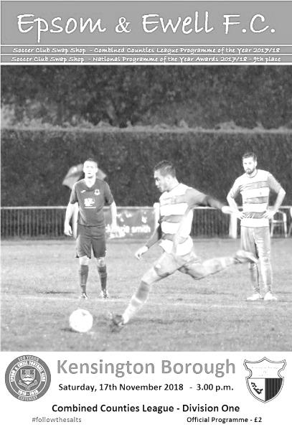
Limp Salts fail to sparkle

On a perfect day for football at Chipstead our boys were ready to extend our winning run to six matches against a lowly placed Kensington Borough. However, our visitors never read the script and produced a very good defensive display, which was coupled with some poor play of our own in the danger area, and left us in a battle to even achieve a point from this match.

In terms of personnel, Captain Scott Murphy returned from suspension, while Luke Elgar returned at the back. They came into the starting eleven in place of the injured David Jones and suspended Steve Betancourt. However, for the first time this season we appeared to have a strong bench too, with Liam Roberts returning from suspension and a few other regular starters there too as competition for places starts to increase.

However, for the third match in a row we started slowly, following the opening exchanges against Ash and Sandhurst. Although Olly Martinez won us an early corner that visiting keeper Hayden Graham did well to punch away under pressure, we created little apart from a decent strike from Reisse Griffin out on the left that Graham stopped from creeping in at his near post. Murphy picked up what looked like a harsh booking shortly after this, while the visitors started to get into the match a bit more.

A low strike from Sebastian Hilogene forced Conor Young into his first save on the quarter hour mark, while another couple of shots were dragged wide. Neither team looked like scoring at this point as the game was contained mostly in midfield, but in the 41st minute the visitors broke through when a right wing cross to the far post was met by Nigel Siedu who struck the ball back across Young into the far corner. In response Rob Hendry hit our first shot on target with a decent low effort from the edge of the box, but as we went in for half time it was clear that we had not asserted any superiority over our opponents and really needed to step up in the second half.

To be fair, that message was clearly given to the players during the interval and the urgency that had been asked for in the first half finally started to appear. Too often though this was accompanied by poor service. Hendry went into this match with six goals from his previous five minutes but was receiving little of quality in the danger area

as the ball just wasn't reaching him often enough. A Hendry corner was met by the head of Jamie Watts but the danger was cleared. Then in the 53rd minute another corner was met at the back post by an acrobatic volley from Murphy that only just cleared the bar. However, we were still vulnerable from time to time and nearly conceded four minutes later when Kensington Borough broke on the right wing, but the low cross in was just met by a defender ahead of the waiting striker.

Roberts entered the fray in place of Roy Gayle and he nearly had an immediate impact, collecting the ball just inside his own half and running all the way through on goal from an angle, but just dragged his shot beyond the far post, while Hendry's free kick did exactly the same. We were on top now though and in the 67th minute Hendry twisted and turned his man before sending a goalbound shot from twenty yards, forcing Graham into a fine save at full stretch for a corner from which Adam Heagney struck a low shot just wide of the post.

It was clear that the addition of Roberts had added an extra dimension to our game and in the 70th minute Hendry's clever reverse pass found him cutting in from the right but again his shot just went past the far post. It would have been a very good goal had it gone in and Roberts then set up Bobby Bennett but the ball bobbled on him and he was unable to keep his shot down.

With sixteen minutes remaining of normal time and the visitors slowing down the match considerably we pushed forward and were caught on the break. A twenty yard strike was well blocked by Young who just reached the loose ball ahead of the incoming striker Ahmed Jibz who was a little late and was booked for his attempts.

Apart from this, we were well in the ascendency, although the defending in numbers from the visitors was smothering our attempts at breaking through. Ironically when we did equalise, it would come as a result of a long ball which Kensington defender Terry Whitman attempted to chest back to Graham, but it went wrong and they conceded the corner. After a number of corners had not beaten the first man, we caught them out with a short one to Lloyd Connelly and his delivery into the area was flicked on by a defender to Hendry at the far post about eight yards out. He then controlled the ball and swept it across Graham low into the far corner for the equaliser in the 81st minute.

We continued to chase a winning goal, but unfortunately it wasn't to come and a free kick from Hendry that sailed well over the bar, which was the final kick of the match, summed up the afternoon. There was plenty of effort but the passing, especially in the final third was really below our usual average and the visitors deserved their point for making it difficult for us in that area. We need to get off to better starts and I genuinely believe that had we done so in this match, it would have made for a comfortable afternoon.

Epsom and Ewell: Conor Young, Luke Elgar, Reisse Griffin, Adam Heagney, Jamie Watts, Lloyd Connelly, Bobby Bennett, Scott Murphy (c), Rob Hendry, Roy Gayle, Olly Martinez

Subs: Liam Roberts for Gayle (61)

From behind the goal
Epsom & Ewell 4-0 Dorkinian F.C.
Surrey Premier Cup – Second Round - Tuesday 20th November 2018

Sweet goals for Salts on bitter evening

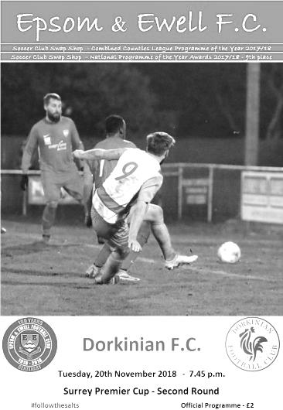
30 hardy souls were present on an extremely cold evening at Chipstead to witness our passage to the Quarter-Final of the Surrey Premier Cup with a 4-0 win over a spirited Dorkinian team. Those who were not here missed some excellent goals too and we finished well on top over the ninety minutes.

So far our progress in this competition has been perfect with two wins, nine goals and two clean sheets and in many ways this was a carbon copy of our First Round win against Knaphill Under 23s in that the opponents competed well and asked some questions but we just had too much for them to deal with in the final third of the pitch. Had it not been for a couple of superb saves from their keeper, Captain and Manager Henry Warne the final tally could have been worse, although we did require Conor Young to make a couple of good saves also to retain the clean sheet, which incidentally is our keeper's 12th for our club and moves him into the top twenty goalkeepers on the club Hall of Fame; only eight of which have a better clean sheet percentage currently.

We made three changes from the team that had performed so sluggishly against Kensington Borough. Steve Betancourt returned from suspension in place of Reisse Griffin, while Ryan Sullivan came in for the injured Roy Gayle and Liam Roberts started in place of the absent Bobby Bennett. Roberts in particular caused the opposition a lot of trouble and had two goals and an assist. There are still occasions when he tries to take on the entire opposition and fails, but his performance was definitely one of the highlights for the shivering crowd, many of whom were too cold even to sit down in the stand, preferring to stand up in most cases!

The Dorkinians, as they are known, were a bit of an unknown proposition playing in the Amateur Football Combination where they sit fourth in the Premier Division and they started off better than us in the opening ten minutes, asking a number of questions. Young made his first save in the 12th minute when he blocked a goal bound effort from close range, then falling on the loose ball, before Liam Hawkins picked up a yellow card for the visitors a minute or two later as they pressed for the opening goal.

We then started to raise our game. In the 17th minute Betancourt struck a low drive from the edge of the area which Warne tipped the ball out for a corner. Six minutes later though we were ahead after the marauding Elgar came in from the right and cleverly flicked the ball with the outside of his foot into the path of Roberts who drilled the ball across Warne from a narrow angle into the far bottom corner of the net from ten yards.

Adam Heagney was next to make a dangerous run from midfield but Warne blocked his attempted cross out for a corner which then failed, like many other recent corners, to clear the first man. We

then had a scare at the other end as Lloyd Connelly dallied on the ball and was robbed. The ball was fed out to the right and when it came back in, it should have been finished off but the striker blazed the ball over the bar from inside the penalty area. They would regret this missed chance soon after as in the 33rd minute we extended our lead. A deep crossfield ball was collected by Roberts in the corner but he beat his man and arrowed in on goal, fizzing the cross over where Olly Martinez was waiting to knock the ball in from four yards. It wasn't quite as straight forward as that however, as Martinez's first touch actually sent the ball up onto the bar but it came back down and was bundled over the line by our player in the same movement!

Martinez then saw his next shot tipped away by Warne. It was a good save as it was going just inside his right hand post, but his next save was world class as the subsequent corner was flicked on to the far post and was met by a really powerful strike at the far post from about ten yards, yet somehow Warne diverted the ball onto the frame of the goal and away when it looked certain to almost break the net. The half concluded with a chance for Heagney after Roberts had crossed from the right, but he scuffed his shot from a good position and Warne made a more routine save this time, but there was still time for an opportunity for the visitors when we stopped, expecting a foul on Rob Hendry which didn't come and they broke away, fortunately finishing with a fairly tame shot straight at the grateful Young.

The second half contained some better possession football from our boys, who had been a bit casual with the ball at times during the first period. One move midway through the half contained some forty Epsom passes, but there was little in the way of real goalmouth action for a while until substitute Elliott Thompson, who had been on the field for just seven minutes, collected the ball in midfield in the 66th minute. He looked to pass but then beat his man. Then he did it again, and a third time, taking him to the edge of the area from where he ran in on goal and casually flicked the ball past the advancing Warne from 12 yards. It was a superb individual goal and possibly tops the list for the season right now.

The goal also killed the match as a contest. As the fine rain turned to sleet for the remainder of the match it was really just a question now of whether we would get a clean sheet or not. The visitors continued to press for their elusive goal and Young did well to tip a shot wide after our offside trap was broken just three minutes later. In the 83rd minute he did really well to deny Oli Wayne by standing up and forcing him wide where he ran the ball out of play.

We were sitting a little deeper at this point and Scott Murphy had a try from 50 yards when he saw Warne on the edge of his area, but he was able to retreat in time to catch the ball on the goal line. Martinez was brought down in full flight by Seth Clenaghan, earning him a yellow card to bring the visitors tally to four and in injury time Wayne saw his shot on goal tipped onto the bar and away by Young. Insult was then added to injury as we broke away and Roberts collected the ball some forty yards out on the right and ran in on goal, rolling the ball across the exposed Warne into the far corner from ten yards in the 92nd minute.

As with the previous round of the Surrey Premier Cup, we really didn't know what to expect from our visitors and it is harder with teams that are not in the pyramid to actually tell what the standard is, but over the ninety minutes we were fairly superior and by the end they were a fairly dispirited bunch. On the final whistle I wished Warne luck for the season and he replied that he hoped he wouldn't see us again. He smiled as he said it, but I think he was being quite serious!

Epsom and Ewell: Conor Young, Luke Elgar, Lloyd Connelly, Adam Heagney,
Steve Betancourt, Jamie Watts, Liam Roberts, Scott Murphy (c), Rob Hendry, Ryan Sullivan,
Olly Martinez

Subs: Germaine Jeannoel for Hendry (54), Elliott Thompson for Sullivan (59),
Scott Elgar for Luke Elgar (71)

This Day in History - 27th November
Date | Day | Competition |  | Opponents |  | Scorers
27/11/26 | Sat | Surrey Senior Cup 4q | H | Carshalton Athletic | 2-2+ | R.Marlow, R.Sperring
27/11/37 | Sat | London League | H | Carshalton Athletic | 2-1 | J.Jones, B.Beglan
27/11/48 | Sat | Surrey Senior Cup 2q | H | Byfleet | 6-1 | T.Goodall, N.Griffiths (2, 1 pen), K.Minter, E.Watkins, F.Chitty
27/11/54 | Sat | Corinthian League | H | Hounslow Town | 5-6 | B.Musto (3), B.Avis (2)
27/11/65 | Sat | Amateur Cup 4q | H | Leyton | 1-4 | K.Welham
27/11/71 | Sat | Athenian League 2 | H | Edgware Town | 1-4 | J.Eales
27/11/74 | Wed | F.A. Vase 2 | A | Horley Town | 2-0 | T.Tuite, T.Wales
27/11/76 | Sat | Athenian League 1 | H | Egham Town | 3-0 | M.Lyel, T.Tuite, K.Eshelby
27/11/79 | Tue | Isthmian League 1 | H | Kingstonian | 1-4 | R.Beswick
27/11/84 | Tue | Isthmian League Premier Division | H | Carshalton Athletic | 1-1 | S.Milton (pen)
27/11/93 | Sat | Isthmian League 3 | A | Kingsbury Town | 3-2 | T.Tweedy (2, 1 pen), A.Rawlinson
27/11/99 | Sat | Isthmian League 3 | A | Bracknell Town | 3-1 | A.Nimmo, S.Grant, R.Sell
27/11/01 | Tue | Surrey Senior Cup 3 | A | Ash United | 4-2+ | S.Hatton (3, 1 pen), C.Barnes
27/11/04 | Sat | Isthmian League 2 | A | Kingsbury Town | 0-1
27/11/07 | Tue | Combined Counties League Cup 3 | A | Chessington & Hook United | 2-1 | B.Hayward, R.Burns
27/11/10 | Sat | Combined Counties Premier Division | A | Ash United | 3-0 | A.McGregor (2), D.Stevens
27/11/17 | Mon | Surrey Senior Cup 1 | A | Sutton Common Rovers | 0-0
Epsom & Ewell won 5-4 on penalties
Historical Decades
Date | Day | Competition |  | Opponents |  | Scorers
90 years ago – Epsom Town F.C.
24/11/28 | Sat | London League | A | Callender Athletic | 1-1 | F.Behn
80 years ago – Epsom F.C.
26/11/38 | Sat | London League | A | R.N.Depot | 4-1 | R.Forbes, A.Curtis, B.Solly, J.Jones
70 years ago – Epsom F.C.
27/11/48 | Sat | Surrey Senior Cup 2q | H | Byfleet | 6-1 | T.Goodall, N.Griffiths (2, 1 pen), K.Minter, E.Watkins, F.Chitty
60 years ago – Epsom F.C.
29/11/58 | Sat | Corinthian League | A | Uxbridge | 2-4 | T.Millard, R.Brunwin
50 years ago – Epsom & Ewell F.C.
23/11/68 | Sat | Surrey Senior Cup 3q | A | Merton Rushmere | 1-1+ | D.Legrice
40 years ago – Epsom & Ewell F.C.
25/11/78 | Sat | Isthmian League 1 | A | Harrow Borough | 1-3 | T.Tuite
30 years ago – Epsom & Ewell F.C.
26/11/88 | Sat | F.A. Vase 2 | H | Three Bridges | 6-2+ | N.Robson (2), P.Andrews, B.Perkins, C.Walcott, C.Holding
20 years ago – Epsom & Ewell F.C.
28/11/98 | Sat | F.A. Vase 2 | A | Fakenham Town | 1-2 | J.Tome
10 years ago – Epsom & Ewell F.C.
22/11/08 | Sat | Combined Counties Premier Division | H | Badshot Lea | 2-0 | K.Hough (pen), R.Shoefield

History Corner – 27th November
92 years ago today we met Carshalton Athletic for the first time ever when paired at home in the Surrey Senior Cup. We led 2-0 at half time through Reg Sperring and Reg Marlow but were hauled back to 2-2 by the end of the 90 minutes and extra time couldn’t separate the clubs. The replay a few weeks later at Colston Avenue against the London League club followed an identical pattern, also finishing 2-2 after extra time, although we would finally win through 5-1 in the second replay with a Marlow hat trick; his first of what would become five consecutive hat tricks, although he would miss a match with flu in that sequence which would turn out to be the next round of this competition against eventual winners Woking, who won 8-3! To this day we have still played the Robins more times than any other club in our history with exception of Camberley Town.

90 years ago this week we visited Callender Athletic for a London League match. They were a works side dealing in cable construction, played in Belvedere, Kent and had come up from the First Division in 1927. In our first London League season together we had won heavily at home but drawn away and the same would occur in 1928/29 where a Fred Behn goal would be the only one scored there by an Epsom player as we drew 1-1. We would win the return match 4-1 four weeks later but they left the league at the end of the season and we never met them again.

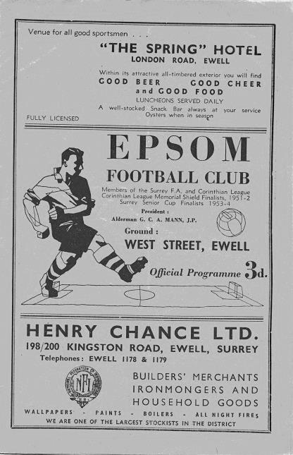
64 years ago today Bobby Musto scored a hat trick, while Bobby Avis scored twice also, yet we still lost this League match at West Street against Hounslow by six goals to five! Musto became a member of a club that to this day contains just eight players in history. We were also 4-2 and 5-3 up during the match. (see programme pictured).

30 years ago this week we were at home to Three Bridges in our first F.A. Vase campaign for eleven seasons. We had defeated Chatham Town and then scraped past Banstead Athletic after extra time but things didn’t look too healthy as we trailed by a goal. However, an Epsom equaliser in the final twenty minutes forced a bizarre period of extra time, still the most incredible in the club’s history, containing six goals and we got five of them to win 6-2!!

17 years ago today a strange game was witnessed by all at Youngs Drive as we defeated Ash United 4-2 after extra time in a Surrey Senior Cup tie. Our keeper Dave Hyatt was delayed so versatile Nigel Bennett started in goal. Simon Hatton put us ahead after 32 minutes but we trailed 2-1 at half time before he equalised with a low drive to force extra time. Chris Barnes then put us ahead before Ash then hit the bar with a penalty, but Hatton completed his hat trick from the spot soon after. 8 years ago today we won there again as two goals from distance by Alex McGregor put us on our way to a 3-0 victory.

1 year ago today our dreadful season provided a rare highlight as we held a weakened Sutton Common Rovers team 0-0 in the Surrey Senior Cup, and with no extra time played, we won 5-4 on penalties. We scored all five of our kicks while Conor Young saved their fourth one and Lloyd Connelly smashed the winning penalty into the net to win the tie. Other successful penalties came from Rob Hendry, Scott Murphy, Adam Heagney and Taryn Smith. Interestingly, all five players are currently still at our club. Merstham ended our “run” in the next round in January 2018 and that was the last game we played in the competition after a run of 94 seasons.

Centre page for results

Centre page for results



EL Records Premier Challenge Cup
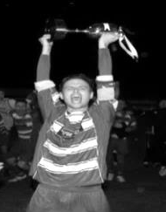
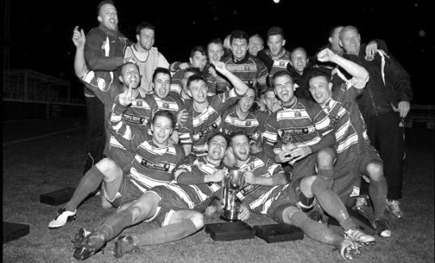
First Round
Camberley Town | 1-3 | Cobham
Horley Town | 0-1 | Chertsey Town
Badshot Lea | 3-1 | Walton & Hersham
FC Deportivo Galicia | 4-1 | Cove
Chessington & Hook United | 2-4 | AFC Hayes
Farnham Town | 1-2 | Southall
Hanworth Villa | 3-1 | Kensington Borough
Second Round
Bedfont & Feltham | 2-0 | Tooting Bec
Sheerwater | 1-0 | Balham
Ash United | 2-3 | Fleet Spurs
Frimley Green | 0-2 | Guildford City
Godalming Town | 2-0 | Dorking Wanderers Reserves
Abbey Rangers | 3-0 | Redhill
FC Deportivo Galicia | 5-0 | AC London
Cobham | 0-3 | AFC Hayes
Abandoned after 88 minutes due to serious player injury - Match awarded to AFC Hayes
CB Hounslow United | 4-1 | Badshot Lea
Hanworth Villa | 2-1 | Sandhurst Town
Epsom & Ewell | 1-0 | Bagshot
Sutton Common Rovers | 4-2 | Southall
Chertsey Town | 3-2 | British Airways
Eversley & California | 1-5 | Knaphill
Banstead Athletic | 4-3 | Colliers Wood United
Spelthorne Sports | 2-1 | Raynes Park Vale
Third Round
FC Deportivo Galicia | V | Sutton Common Rovers
AFC Hayes | V | Bedfont & Feltham
Epsom & Ewell | V | Godalming Town
Sheerwater | V | Banstead Athletic
Guildford City | V | CB Hounslow United
Spelthorne Sports | V | Hanworth Villa
Knaphill | V | Fleet Spurs
Chertsey Town | V | Abbey Rangers

CCL Division One Club Directory
AC LONDON: Telephone: 0208 660 5491 - Colours: Orange/Black/Black
Ground: Whyteleafe FC - 15 Church Road, Whyteleafe. CR3 0AR

ASH UNITED: Telephone: 01252 344264 - Colours: Green with Red Trim/Green/Green
Ground: Shawfields Stadium, Youngs Drive, Shawfields Road, Ash, Aldershot. GU12 6RE

BAGSHOT: Telephone: 01252 623804 - Colours: Yellow/Black/Black
Ground: Fleet Town FC - Calthorpe Park, Crookham Road, Fleet. GU51 5FA

BEDFONT & FELTHAM: Telephone: 0208-890 7264 - Colours: Yellow/Blue/Blue

Ground: The Orchard, Hatton Road, Bedfont. TW14 9QT

BRITISH AIRWAYS: Telephone: 0208-890 7264 - Colours: Sky Blue/Navy Blue/Navy Blue
Ground: Bedfont & Feltham FC - The Orchard, Hatton Road, Bedfont. TW14 9QT

CHESSINGTON & HOOK UNITED: Telephone: 01372-602263 Colours: All Blue
Ground: Chalky Lane, Chessington. KT9 2NF

COVE: Telephone: 01252 543615 Colours: Yellow/Black/Black
Ground: Oak Farm, Squirrel Lane, Cove GU14 8PB

DORKING WANDERERS RES Telephone: 01306 400151 - Colours: Red & White Stripes/ Blue/ Red
Ground: Meadowbank Stadium, Mill Lane, Dorking. RH4 1DX

EPSOM & EWELL Telephone: 01737-553250 - Colours: Royal Blue & White Hoops/Royal Blue/Royal Blue - Ground: Chipstead FC, High Road, Chipstead. CR5 3SF

EVERSLEY & CALIFORNIA Telephone: 0118 973 2400 - Colours: - White & Royal Blue Hoops /Royal Blue/ Royal Blue - Ground: Fox Lane, off Reading Road, Eversley. RG27 0NS

FARNHAM TOWN Telephone: 01252 715305 - Colours: - Claret & Sky Blue /White/ Claret & Blue
Ground: Memorial Ground, Babbs Mead, West Street, Farnham. GU9 7DY

FC DEPORTIVO GALICIA Telephone: 0208 831 9067 - Colours: Royal Blue/Royal Blue/White
Ground: Bedfont Sports FC - Bedfont Sports Club, Hatton Road, Bedfont. TW14 9JR

FLEET SPURS Telephone: 01252 662810 - Colours: Dark Blue with Red Trim/Dark Blue/Dark Blue
Ground: Kennels Lane Farnborough. GU14 0ST

FRIMLEY GREEN Telephone: 01252 835089 - Colours: All Blue
Ground: Frimley Green Recreation Ground, Frimley Green Road, Frimley. GU16 6JY

GODALMING TOWN Telephone: 01483 417520 - Colours: Yellow/Green/Yellow
Ground: Wey Court, Meadrow, Godalming. GU7 3JE

KENSINGTON BOROUGH Telephone: 01372 360151 - Colours: All Blue
Ground: Leatherhead FC – Fetcham Grove, Guildford Road, Leatherhead. KT22 9AS

SANDHURST TOWN Telephone: 01252 878768 - Colours: Red & Black Stripes/Black/Black
Ground: Bottom Meadow, Sandhurst Memorial Park, Yorktown Road, Sandhurst. GU47 9BJ

SHEERWATER Telephone: 01483 772470 - Colours: Royal Blue & White/Royal Blue/Royal Blue
Ground: Woking FC - Laithwaite Community Stadium, Kingfield, Kingfield Road, Woking. GU22 9AA

TOOTING BEC Telephone: 0208 540 8843 - Colours: Black & White Stripes/White/White & Black
Ground: Raynes Park Vale FC – Prince George’s Playing Fields, Grand Drive, Raynes Park. SW20 9DZ

Combined Counties League Premier Division
Opponents All-time Records
inc Saturday  24th November | P | W | D | L | F | A | PPG | GD | Best  Win | Worst  Loss
Bedfont & Feltham | 2 | 2 | 0 | 0 | 13 | 3 | 3.00 | +10 | 9-2 | -
AC London | 1 | 1 | 0 | 0 | 6 | 0 | 3.00 | +6 | 6-0 | -
Bagshot | 2 | 2 | 0 | 0 | 4 | 0 | 3.00 | +4 | 3-0 | -
FC Deportivo Galicia | 1 | 1 | 0 | 0 | 3 | 0 | 3.00 | +3 | 3-0 | -
Tooting Bec | 1 | 1 | 0 | 0 | 3 | 1 | 3.00 | +2 | 3-1 | -
Fleet Spurs | 1 | 1 | 0 | 0 | 3 | 2 | 3.00 | +1 | 3-2 | -
Frimley Green | 11 | 9 | 1 | 1 | 35 | 5 | 2.55 | +30 | 7-1 | 0-1
Godalming Town | 3 | 2 | 0 | 1 | 4 | 5 | 2.00 | -1 | 2-1 | 0-3
Ash United | 20 | 11 | 3 | 6 | 50 | 32 | 1.80 | +18 | 6-0 | 0-3
Farnham Town | 18 | 9 | 4 | 5 | 31 | 29 | 1.72 | +2 | 3-0 | 1-4
Cove | 35 | 16 | 9 | 10 | 78 | 57 | 1.63 | +21 | 7-0 | 1-6
Chessington & Hook Utd | 30 | 13 | 9 | 8 | 63 | 45 | 1.60 | +18 | 6-0 | 1-3
Sheerwater | 5 | 2 | 2 | 1 | 10 | 5 | 1.60 | +5 | 3-0 | 2-3
Sandhurst Town | 16 | 7 | 0 | 9 | 28 | 28 | 1.31 | 0 | 4-0 | 1-3
Kensington Borough | 1 | 0 | 1 | 0 | 1 | 1 | 1.00 | 0 | - | -
British Airways | 1 | 0 | 0 | 1 | 2 | 3 | 0.00 | -1 | - | 2-3
Eversley & California | 1 | 0 | 0 | 1 | 1 | 2 | 0.00 | -1 | - | 1-2
Dorking Wanderers Res | 1 | 0 | 0 | 1 | 3 | 5 | 0.00 | -2 | - | 3-5

Player Sponsorship
Here is the latest list for 2018/19, with new photos showing all of our players and Management that are available for sponsorship.

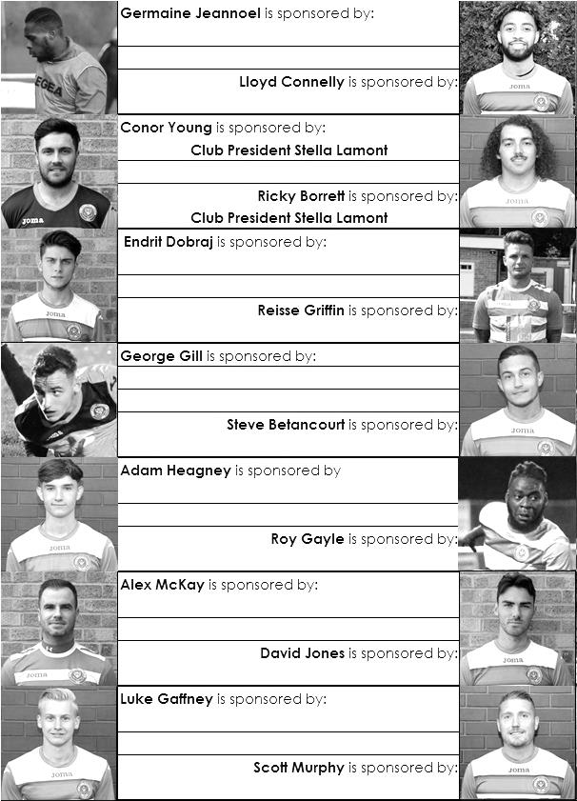

Sponsorship costs just £40 and it is easy to do. Just select a player who has not been previously sponsored and let a Committee Member know that you would like to sponsor them. Beware though. Until we have received the money it is possible for someone to jump in front of you, so don’t delay, sponsor today!
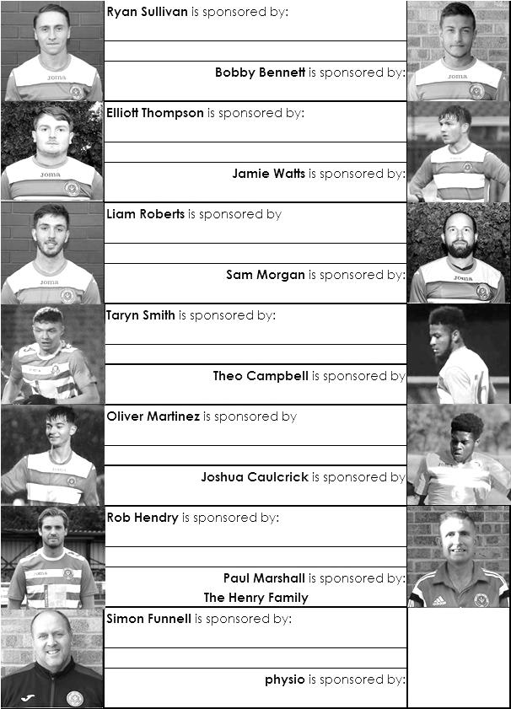

Previous Managers

In our latest instalment we a difficult time for the club as we entered the sixties in disarray.

Derek Evans – Manager 6th February 1961 – 22nd August 1961
Doug Whitehead (caretaker) – August 1961 – January 1962
Selection Committee – January 1962 – August 1962
Ray Chenery – July 1962 – September 1962
Fred Chitty – September 1962 – May 1963

The sixties were a terrible time for our club. Results wise, it was easily or worst decade in history and it wasn’t helped by the turbulence at the club in terms of Managers. Derek Evans had been hastily appointed to replace the unpopular Bill Kennedy in February 1961. An England Amateur International while at Hounslow he had been a very good player and was only 31 so would strengthen the team too it was hoped. He was just coming back from a year out with injury but the quality was there. He lived in Colnbrook, near Slough at the time.

One of his first decisions related to long-serving legend Ernie Watkins. He had been with the club since 1945 and had spent the season in the Reserves to this point. He wrote to the club to ask if his services were still required so the Committee referred the request to Evans, and whilst the response is not recorded, Watkins left for Banstead Athletic within a matter of weeks. It was to prove a big mistake as Ernie would go on to play for them for another eight seasons until retiring in 1968 at the age of 47!

In March Evans was injured in a 5-0 home defeat to Chesham United and would miss the remainder of the season. However, the new season did not start well. Evans was due at a meeting on 22nd August to select a team for the next match 24 hours later but wasn’t present so the Committee understandably had no choice but to pick the team. When Evans found out he asked the Committee to change the team or he would resign but the Committee held their ground and whilst Evens still played in the match; a 2-2 draw at Erith & Belvedere, he resigned the next day, returning to Hounslow where he would become one of the eleven who would represent them in their finest hour; the Amateur Cup Final at Wembley in April 1962 and also the losing replay, along with another Epsom player Ken McDonald who also left at this time. Evans died in March 1991 at the age of 62.

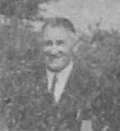
He was replaced shortly after this by former Manager Doug Whitehead (pictured) who attempted to steady the ship and did fairly well up until Christmas but resigned at that point, leaving the club to revert to a Selection Committee for the first time in many years. That Committee was made up of Press Secretary Ken Knowlson (pictured across page on left), Reserve Team Manager Ray Chenery (pictured across page on right), and Chairman Peter Carpenter, but it all went wrong in the New Year. A narrow defeat to Dulwich Hamlet in the County Cup gave grounds for optimism, but it was then followed by ten straight losses in the league, despite having a 16 year old future Amateur International Larry Pritchard and future Football League player John Leedham. Also in goal was Glyn Howells, father of future Tottenham legend David.

Two wins and five defeats ended the season as we finished one place from the foot of the table and it is not clear exactly how it happened but the Selection Committee was disbanded and Ray Chenery took the helm for the 1962/63 season. Ray was born in 1925 and was a local lad who had played during the war briefly and even met his wife Glenys at the ground. He had many years of service at the club yet lasted in this role for just two months before leaving. He quoted personal reasons but would not return to the club for 45 years, only coming back to watch a couple of matches after I had many conversations with him over the creation of the Club History Book, Two
Legs Not Four, which came out in 2007. He was a really nice chap with a great sense of humour and a great memory, providing significant contributions to the book, although regrettably he passed away in September 2008 aged 83.

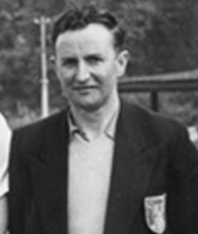
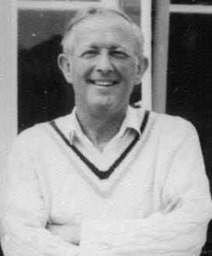
Of course, the club had to replace Chenery and clearly did not fancy the Selection Committee idea again so they went back to a well-known face in Fred Chitty. Fred had been Manager from 1956 to 1959 and his earlier tenure was covered in a previous issue. Recently he had been at Banstead Athletic before scouting briefly at Carshalton Athletic, but on his return it was clear that the club had changed significantly since his previous time in charge. With a very young team which had some potential, but no experience, it was a difficult season and only home and away wins over wooden spoonists Wembley enabled us to finish one place above the bottom once again.

Chitty had been assisted for a while by Tommy Rochester who he had been in tandem with during his earlier spell in charge. We still had some good players and alongside Pritchard came a youngster by the name of Colin Murphy who would become very famous as a Manager at Derby County and Lincoln City amongst other clubs.

Meanwhile, Rochester had been unwell during the season and by March it was Albert ‘Gil’ Gillings who was the Coach, having offered his services to the club. Gillings was a former player at Sutton United and was now a qualified Coach. When Chitty resigned in May 1963, the club chose to give Gillings the job, which was beginning to look like a poisoned chalice!

Match and Ball Sponsorships – 2018/19
Opponent | Date | Match Sponsor | Ball Sponsor
Chessington & Hook Utd | 21/08/18 | Club President - Stella Lamont
Beckenham Town (FAC) | 28/08/18 | Building Shop Ltd
Cove | 08/09/18 | EEFC Management Committee
Tooting Bec | 15/09/18 | Building Shop Ltd
Bagshot (LC) | 25/09/18
Sheerwater | 06/10/18 | Paul Merritt
Knaphill U23  (Surrey Premier Cup) | 23/10/18 | Jack Jarman
Frimley Green | 03/11/18 | Our Chairman’s Grandchildren – George, Joseph, Ezara and Inaya
Sandhurst Town (LD1C) | 06/11/18 | Richard Lambert
Kensington Borough | 17/11/18 | Jeff & Arnold Pye
Dorkinian (SPC) | 20/11/18
Dorking Wanderers Res | 27/11/18
Godalming Town | 01/12/18
Bedfont & Feltham | 08/12/18
Eversley & California | 29/12/18
Ash United | 12/01/19
Bagshot | 19/01/19
Farnham Town | 02/02/19
British Airways | 16/02/19
AC London | 02/03/19
FC Deportivo Galicia | 12/03/19
Fleet Spurs | 06/04/19
Sandhurst Town | 20/04/19 | Club President - Stella Lamont
Godalming Town (LC) |  | Date unknown
Unknown (SPC) |  | 3rd Round – might be at home
Match sponsorship costs just £60.00!

Sponsorship includes:

Admission, programmes and hospitality for three people.

A full page advert in the programme and mascot for the day (if required).

If you are interested, just speak to a Committee Member,
or drop me an email at: richard.c.lambert@gmail.com

Dorking Wanderers – History
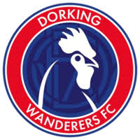
Football was first played in Dorking in the 1830s. The game was played in the street with the East and West of the town competing against each other in the annual Shrove Tuesday game.

The first senior club, called Dorking FC, was formed in1880 and became founder members of Surrey FA, while playing local rivals in the Surrey Senior League at West Bank, before moving to Fairfield Drive and on to Pixham Lane in the 1920s, where the club was reformed for the first of several times.

Football in Dorking became quite literally central to the town in 1953, when a new stadium was built at Meadowbank - an iconic, picturesque location just behind the High Street. Among many memorable occasions in the Corinthian and Athenian Leagues, the stadium’s high point came in 1992 when a record-breaking crowd saw the latest version of Dorking FC take on Peter Shilton’s Plymouth Argyle in the first round proper of the FA Cup.

Unfortunately, there was to be no happy ending as, not only did the visitors secure a narrow 3-2 win, but Meadowbank never witnessed such heady days again. Two decades of under-investment and decline saw a dilapidated Meadowbank stadium, once the pride of Dorking, closed for health and safety reasons in 2013.

Meanwhile, Dorking Wanderers FC had been established in 1999. Founder members Marc White, Peter Buckland, Mark Lewington, Ian Davidson, Lee Spickett and Penny Gregg entered a fledgling team into the Crawley & District League, with home games played at Big Field in Brockham.

The club remained at its village location for eight years until, after several promotions it relocated to its current Westhumble home. This was a monumental project, which saw a huge off the field effort transform the once derelict site into a new, senior standard football ground.

The promotions kept coming and, in 2015, the club finished runners-up in the Sussex County League, securing promotion to the Ryman League.

A year later, despite finishing runners up in the Ryman Division One South, Dorking Wanderers were denied a second successive promotion in the play-offs. But it was a different story in 2016-17. Goal difference meant Dorking were runners up once again - despite matching the champions Tooting and Mitcham’s huge haul of 105 points - and this time promotion was won with play-off victories over Hastings and Corinthian Casuals.

These are truly boom times for Dorking football. The 2017-18 campaign saw the club line up for the first time in the Bostik Premier League – the highest standard to date in the town’s long history. And that has been followed by the return of local football to its ancestral seat at Meadowbank, with a multi-million pound stadium opening in July 2018, providing a new, state-of-the-art town centre home for Dorking Wanderers, and a base for future progress on and off the pitch.

The Dorking Wanderers Reserves have a firm commitment to develop local talent for the first team. They are the final piece of the club’s player pathway and ensure that the best local players have maximum opportunity to progress and represent their home town in the first team. The new team will compete in the Combined Counties League Division One, three tiers below Dorking’s Bostik Premier League side.

The Dorking Wanderers Reserves team is managed by Jordan Clark and Peter Augustine. Jordan has been instrumental in setting up the club’s academy which competes with the very best in the South East of England and Peter works full time for the Football Association as a County Coach Developer, supporting coaches and their training throughout Surrey.

Combined Counties League – Division One
Tuesday, 27th November 2018 - Kick-off 7.45 p.m.
Epsom and Ewell  (Royal Blue & White hoops) | V |  | Dorking Wanderers Reserves  (Red/White Shirt / Blue / Rec )
Squad | NUMBERS |  | Squad
Conor Young |  |  | Drew Churchwell
Ricky Borrett |  |  | Teddy Ralph
Luke Elgar |  |  | Daniel Crunden Jones
Reisse Griffin |  |  | George Peterkin ©
Lloyd Connelly |  |  | Syrus Stewart
Jamie Watts |  |  | Rory Sellick
Steve Betancourt |  |  | Festus Ediku
David Jones |  |  | Elliott Downs
Endrit Dobraj |  |  | Pascal Sedgwick
Adam Heagney |  |  | Maxwell Iyamu
Ryan Sullivan |  |  | Ben Dyson
Liam Roberts |  |  | Josh Burt
© Scott Murphy |  |  | Clarence Ngunza Mbulu
Scott Elgar |  |  | James Dixon
Elliott Thompson |  |  | Louis O’Brien
Bobby Bennett |  |  | George Coffey
Rob Hendry |  |  | Paris Mason
Roy Gayle |  |  | Callum Manning
Olly Martinez |  |  | Luke Cunningham
Germaine Jeannoel
Joshua Caulcrick
Taryn Smith
Simon Funnell | MANAGER |  | Jordan Clark
Matt Drew | ASST MANAGER |  | Tom Fletcher / Ali Esmail
Sam Morgan | COACHES |  | Peter Augustine
 | PHYSIO |  | Andrew Bushe
REFEREE: A.Rafique
ASSISTANTS: M.Ford, I.Hempel

OUR NEXT VISITORS TO HIGH ROAD
Godalming Town
Combined Counties League – Division One
Saturday, 1st December 2018 – 3.00 pm

